CSE421: Computer Network

Project Title: Attack on Finances (AoF)

*Submitted By:*

Group-201

|  |  |
| --- | --- |
| **Student ID** | **Student Name** |
| 19101077 | Mohammad Shafkat Hasan |
| 18101698 | Muhtasim Fuad Ayon |
| 20101607 | Mahpara Chowdhury |
| 18301182 | Aseer Iqtider Chowdhury |

Date of Submission:

14th April 2023

# Network Topology:

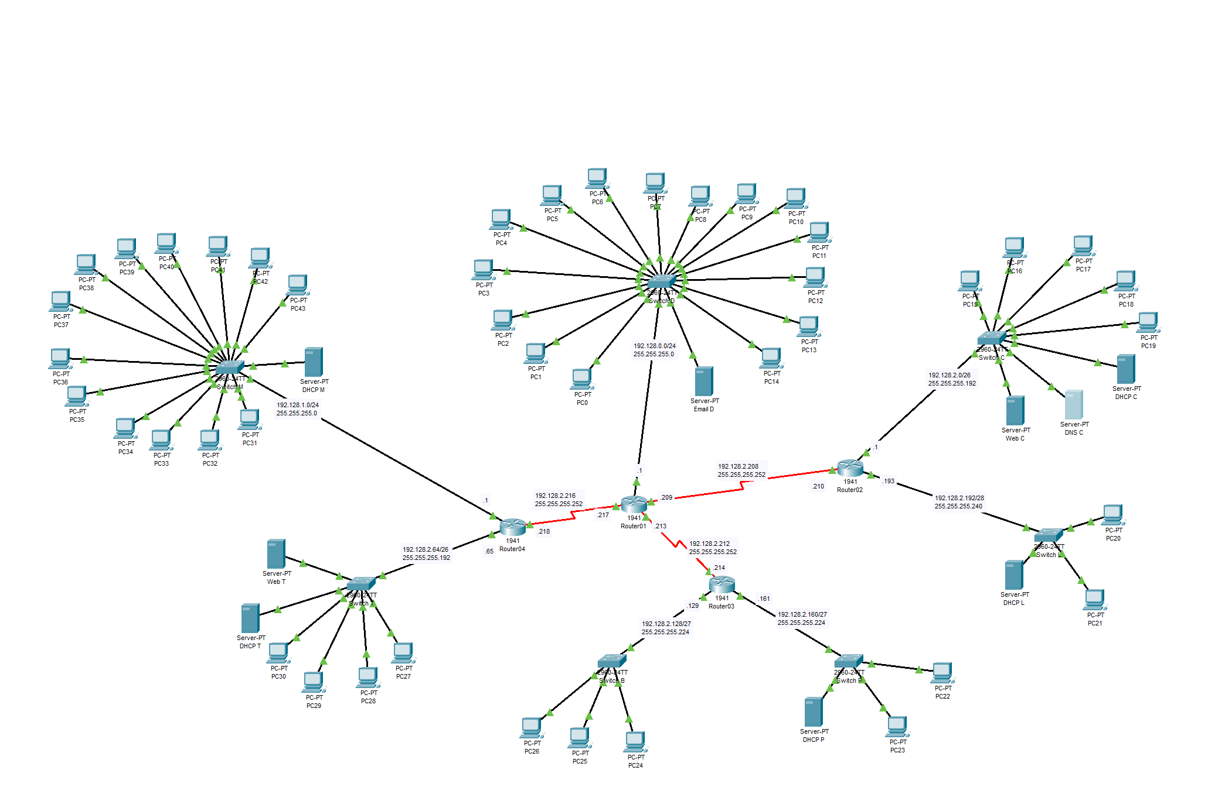

**VLSM TREE:**

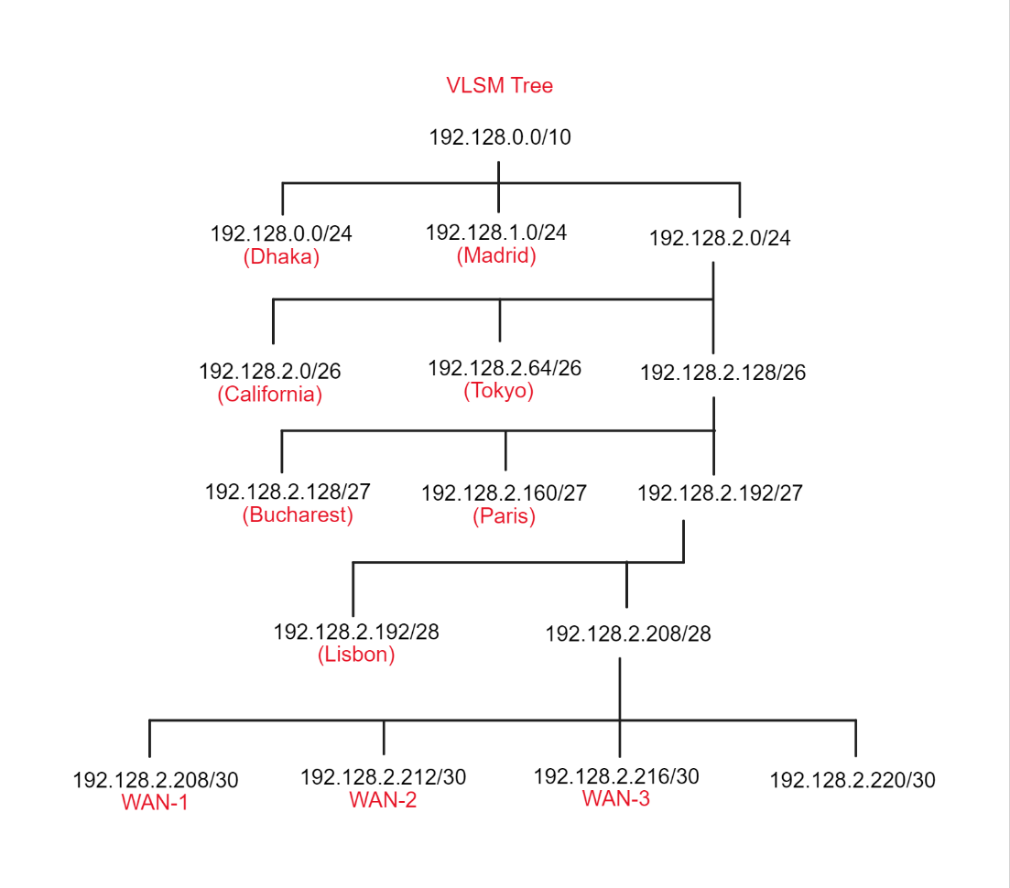

# Addressing Table

|  |  |  |  |  |
| --- | --- | --- | --- | --- |
| **Device** | **Interface** | **IP Address Prefix** | **Subnet Mask** | **Default Gateway** |
| Router01 | G0/0 | 192.128.0.1 | 255.255.255.0 | N/A |
| S0/0/0 | 192.128.2.209 | 255.255.255.252 | N/A |
| S0/0/1 | 192.128.2.213 | 255.255.255.252 | N/A |
| S0/1/0 | 192.128.2.217 | 255.255.255.252 | N/A |
| Router02 | G0/0 | 192.128.2.1 | 255.255.255.192 | N/A |
| G0/1 | 192.128.2.193 | 255.255.255.240 | N/A |
| S0/0/0 | 192.128.2.210 | 255.255.255.252 | N/A |
| Router03 | G0/0 | 192.128.2.161 | 255.255.255.224 | N/A |
| G0/1 | 192.128.2.129 | 255.255.255.224 | N/A |
| S0/0/1 | 192.128.2.214 | 255.255.255.252 | N/A |
| Router04 | G0/0 | 192.128.2.65 | 255.255.255.192 | N/A |
| G0/1 | 192.128.1.1 | 255.255.255.0 | N/A |
| S0/1/0 | 192.128.2.218 | 255.255.255.252 | N/A |

|  |  |  |  |  |  |
| --- | --- | --- | --- | --- | --- |
| **Device** | **Interface** | **IP Address Prefix** | **Subnet Mask** | **Default Gateway** | **DNS Server** |
| PC0 | Fa0 | 192.128.0.2 | 255.255.255.0 | 192.128.0.1 | 192.128.2.11 |
| PC1 | Fa0 | 192.128.0.3 | 255.255.255.0 | 192.128.0.1 | 192.128.2.11 |
| PC2 | Fa0 | 192.128.0.4 | 255.255.255.0 | 192.128.0.1 | 192.128.2.11 |
| PC3 | Fa0 | 192.128.0.5 | 255.255.255.0 | 192.128.0.1 | 192.128.2.11 |
| PC4 | Fa0 | 192.128.0.6 | 255.255.255.0 | 192.128.0.1 | 192.128.2.11 |
| PC5 | Fa0 | 192.128.0.7 | 255.255.255.0 | 192.128.0.1 | 192.128.2.11 |
| PC6 | Fa0 | 192.128.0.8 | 255.255.255.0 | 192.128.0.1 | 192.128.2.11 |
| PC7 | Fa0 | 192.128.0.9 | 255.255.255.0 | 192.128.0.1 | 192.128.2.11 |
| PC8 | Fa0 | 192.128.0.10 | 255.255.255.0 | 192.128.0.1 | 192.128.2.11 |
| PC9 | Fa0 | 192.128.0.11 | 255.255.255.0 | 192.128.0.1 | 192.128.2.11 |
| PC10 | Fa0 | 192.128.0.12 | 255.255.255.0 | 192.128.0.1 | 192.128.2.11 |
| PC11 | Fa0 | 192.128.0.13 | 255.255.255.0 | 192.128.0.1 | 192.128.2.11 |
| PC12 | Fa0 | 192.128.0.14 | 255.255.255.0 | 192.128.0.1 | 192.128.2.11 |
| PC13 | Fa0 | 192.128.0.15 | 255.255.255.0 | 192.128.0.1 | 192.128.2.11 |
| PC14 | Fa0 | 192.128.0.16 | 255.255.255.0 | 192.128.0.1 | 192.128.2.11 |
| Email D | Fa0 | 192.128.0.20 | 255.255.255.0 | 192.128.0.1 | 192.128.2.11 |
| PC15 | Fa0 | 192.128.2.2 | 255.255.255.192 | 192.128.2.1 | 192.128.2.11 |
| PC16 | Fa0 | 192.128.2.3 | 255.255.255.192 | 192.128.2.1 | 192.128.2.11 |
| PC17 | Fa0 | 192.128.2.4 | 255.255.255.192 | 192.128.2.1 | 192.128.2.11 |
| PC18 | Fa0 | 192.128.2.5 | 255.255.255.192 | 192.128.2.1 | 192.128.2.11 |
| PC19 | Fa0 | 192.128.2.6 | 255.255.255.192 | 192.128.2.1 | 192.128.2.11 |
| DHCP C | Fa0 | 192.128.2.10 | 255.255.255.192 | 192.128.2.1 | 192.128.2.11 |
| DNS C | Fa0 | 192.128.2.11 | 255.255.255.192 | 192.128.2.1 | 192.128.2.11 |
| Web C | Fa0 | 192.128.2.12 | 255.255.255.192 | 192.128.2.1 | 192.128.2.11 |
| PC20 | Fa0 | 192.128.2.194 | 255.255.255.240 | 192.128.2.193 | 192.128.2.11 |
| PC21 | Fa0 | 192.128.2.195 | 255.255.255.240 | 192.128.2.193 | 192.128.2.11 |
| DHCP L | Fa0 | 192.128.2.200 | 255.255.255.240 | 192.128.2.193 | 192.128.2.11 |
| PC22 | Fa0 | 192.128.2.162 | 255.255.255.224 | 192.128.2.161 | 192.128.2.11 |
| PC23 | Fa0 | 192.128.2.163 | 255.255.255.224 | 192.128.2.161 | 192.128.2.11 |
| DHCP P | Fa0 | 192.128.2.170 | 255.255.255.224 | 192.128.2.161 | 192.128.2.11 |
| PC24 | Fa0 | 192.128.2.130 | 255.255.255.224 | 192.128.2.129 | 192.128.2.11 |
| PC25 | Fa0 | 192.128.2.131 | 255.255.255.224 | 192.128.2.129 | 192.128.2.11 |
| PC26 | Fa0 | 192.128.2.132 | 255.255.255.224 | 192.128.2.129 | 192.128.2.11 |
| PC27 | Fa0 | 192.128.2.66 | 255.255.255.192 | 192.128.2.65 | 192.128.2.11 |
| PC28 | Fa0 | 192.128.2.67 | 255.255.255.192 | 192.128.2.65 | 192.128.2.11 |
| PC29 | Fa0 | 192.128.2.68 | 255.255.255.192 | 192.128.2.65 | 192.128.2.11 |
| PC30 | Fa0 | 192.128.2.69 | 255.255.255.192 | 192.128.2.65 | 192.128.2.11 |
| DHCP T | Fa0 | 192.128.2.70 | 255.255.255.192 | 192.128.2.65 | 192.128.2.11 |
| Web T | Fa0 | 192.128.2.72 | 255.255.255.192 | 192.128.2.65 | 192.128.2.11 |
| PC31 | Fa0 | 192.128.1.2 | 255.255.255.0 | 192.128.1.1 | 192.128.2.11 |
| PC32 | Fa0 | 192.128.1.3 | 255.255.255.0 | 192.128.1.1 | 192.128.2.11 |
| PC33 | Fa0 | 192.128.1.4 | 255.255.255.0 | 192.128.1.1 | 192.128.2.11 |
| PC34 | Fa0 | 192.128.1.5 | 255.255.255.0 | 192.128.1.1 | 192.128.2.11 |
| PC35 | Fa0 | 192.128.1.6 | 255.255.255.0 | 192.128.1.1 | 192.128.2.11 |
| PC36 | Fa0 | 192.128.1.7 | 255.255.255.0 | 192.128.1.1 | 192.128.2.11 |
| PC37 | Fa0 | 192.128.1.8 | 255.255.255.0 | 192.128.1.1 | 192.128.2.11 |
| PC38 | Fa0 | 192.128.1.9 | 255.255.255.0 | 192.128.1.1 | 192.128.2.11 |
| PC39 | Fa0 | 192.128.1.10 | 255.255.255.0 | 192.128.1.1 | 192.128.2.11 |
| PC40 | Fa0 | 192.128.1.11 | 255.255.255.0 | 192.128.1.1 | 192.128.2.11 |
| PC41 | Fa0 | 192.128.1.12 | 255.255.255.0 | 192.128.1.1 | 192.128.2.11 |
| PC42 | Fa0 | 192.128.1.13 | 255.255.255.0 | 192.128.1.1 | 192.128.2.11 |
| PC43 | Fa0 | 192.128.1.14 | 255.255.255.0 | 192.128.1.1 | 192.128.2.11 |
| DHCP M | Fa0 | 192.128.1.20 | 255.255.255.0 | 192.128.1.1 | 192.128.2.11 |

# All Commands

Router01

en

conf t

int g0/0

ip address 192.128.0.1 255.255.255.0

no shut

exit

int s0/0/0

ip address 192.128.2.209 255.255.255.252

no shut

exit

int s0/0/1

ip address 192.128.2.213 255.255.255.252

no shut

exit

int s0/1/0

ip address 192.128.2.217 255.255.255.252

no shut

exit

ip route 192.128.1.0 255.255.255.0 192.128.2.218

ip route 192.128.2.64 255.255.255.192 192.128.2.218

ip route 192.128.2.160 255.255.255.224 192.128.2.214

ip route 192.128.2.128 255.255.255.224 192.128.2.214

ip route 192.128.2.0 255.255.255.192 192.128.2.210

ip route 192.128.2.192 255.255.255.240 192.128.2.210

Router02

en

conf t

int g0/0

ip address 192.128.2.1 255.255.255.192

no shut

exit

int g0/1

ip address 192.128.2.193 255.255.255.240

no shut

exit

int s0/0/0

ip address 192.128.2.210 255.255.255.252

no shut

exit

ip route 192.128.0.0 255.255.252.0 192.128.2.209

Router03

en

conf t

int g0/0

ip address 192.128.2.161 255.255.255.224

no shut

exit

int g0/1

ip address 192.128.2.129 255.255.255.224

no shut

exit

int s0/0/1

ip address 192.128.2.214 255.255.255.252

no shut

exit

ip route 192.128.0.0 255.255.252.0 192.128.2.213

Router04

en

conf t

int g0/1

ip address 192.128.1.1 255.255.255.0

no shut

exit

int g0/0

ip address 192.128.2.65 255.255.255.192

no shut

exit

int s0/1/0

ip address 192.128.2.218 255.255.255.252

no shut

exit

ip route 192.128.0.0 255.255.252.0 192.128.2.217